Bandit Level 4
DG Interns Hub | Week 1 | OverTheWire Bandit Writeup

Objective
Locate a hidden file in a directory.

Activity summary
Suggested learning command / approach: ls -la inhere; cat inhere/.*. Use only on the authorized OverTheWire training environment.

Key learning
Listing hidden files.

Evidence
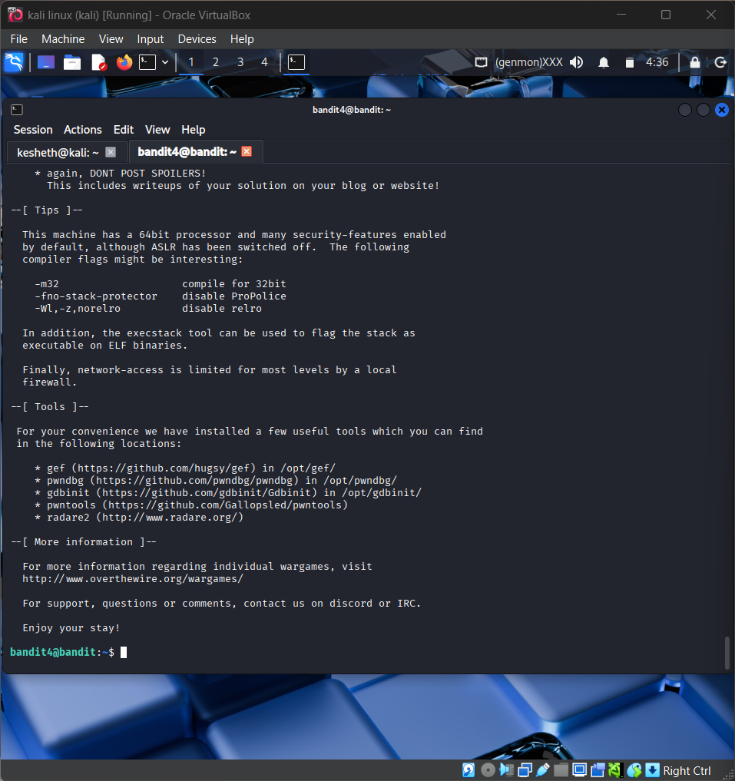
Screenshot: Bandit_Level_4.png
The screenshot is evidence of level activity/login; it may not show every solution step. No passwords are reproduced.

